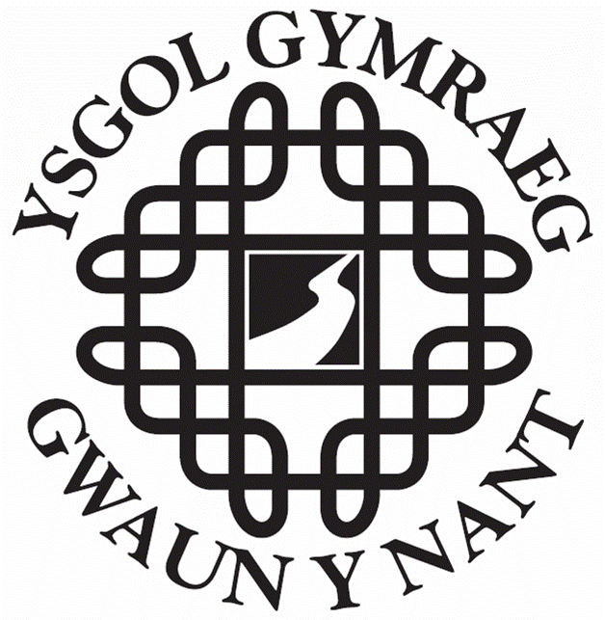
YSGOL GYMRAEG GWAUN Y NANT

FOOD AND FITNESS POLICY

The aims of this policy are to:

- improve the health of the whole school community by equipping pupils with the knowledge and skills to establish and maintain life-long active lifestyles and healthy eating habits.
- ensure that food and nutrition and physical activity become integral to the overall school, and that it runs through the curriculum, the school environment and links with the wider community.
- develop a whole school approach to food and fitness policy that offers a shared vision, facilitates discussion, encourages wide engagement of stakeholders and establishes belief and ownership in the aims and objectives it aspires to.

The objectives of this policy are to:

Ethos
- recognise the significant impact of the informal curriculum on the personal social and emotional education of pupils as well as their physical health and well being.
- understand and maximise opportunities for social and educational development through the organisation and delivery of food and fitness activity throughout the day.
- ensure that all activities and services related to food and fitness provided for pupils throughout the school day are consistent with the food and fitness content of the curriculum and appropriate national guidance and regulation.
- ensure wherever possible that pupils are involved in the decision making process relating to food and fitness activities.

Curriculum

- ensure that the curriculum offers all pupils an understanding of the relationship between food, physical activity and short and long term health benefits.
- implement a well planned National Curriculum course of study in health-related exercise, as part PE, part School Sport Programme, making good use of opportunities for cross-curricular promotion of physical activity and its relationship to diet and nutrition.
- offer a programme of work that provides basic skills including the purchasing, preparing and cooking of food

Environment

- ensure the operation, scope and delivery of the food and drink service meets with the general health promoting ethos of the school.
- ensure the provision of a range of safe and stimulating sport and recreational activities outside of the formal curriculum.
- ensure maintenance and utilisation of outdoor space in accordance with the Foundation Phase Curriculum.
- facilitate safe and environmentally friendly ways to get to and from school where appropriate.

Community

- raise awareness of and promote the food and fitness activities and policy of the school in partnership with key community and health agencies.
- collect, collate and provide pupils with appropriate information about opportunities and resources available relating to food, nutrition, physical activity and sport in the community.
- develop alliances and partnerships with local providers where possible.
- provide an out of school hours programme that is broad and purposeful and includes enjoyable food and fitness pursuits for pupils and staff.

The following groups of people will be responsible for the implementation of this policy:
Governors, including parents
Head teacher and staff
Eco Committee
Healthy School Coordinator
School cook

Implementation and monitoring:
The Head teacher and Governing Body will be responsible for the implementation and review of this policy.
The policy will be reviewed and amended in response to additional guidance.

Related documents:

Developing a Whole School Food and Fitness Policy (2007) Welsh Assembly Government. Available from www.healtheschool.org.uk (teachers section).
Food and Fitness- Promoting Healthy Eating and Physical Activity for Children and Young People in Wales. 5 Year Implementation plan. (2006). Available from www.wales.gov.uk/cmopublications (Publications Catalogue).
Appetite for Life (2006). Available from www.learningwales.gov.uk.
Food in schools Assessment Tool (2004, 2007). Available from www.wales.gov.uk/cmopublications.
Physical Activity in School Assessment Tool (2006). Available from www.wales.gov.uk/cmopublications.
Healthier Lunchboxes Ideas for Primary Schools (2007). Available from www.healtheschool.org.uk (teachers section, nutrition).

